***LOHANA SCHOOLS***

***REVISION WORK FOR BABY: 2020***

***ACTIVITY TWO***

**LOHANA SCHOOLS**

**Interacting, exploring, knowing and using my environment. - Learning Area 2 – Drawing**

**I like colouring**.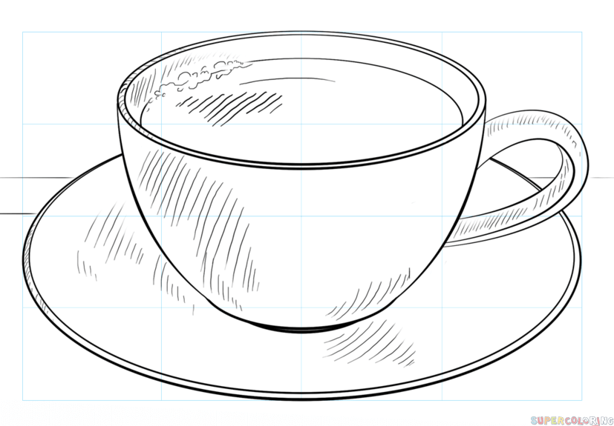

***REVISION WORK FOR BABY ACTIVITY TWO:2020***

**Developing and using my language appropriately. Learning Area 5 – (English)**

My name is …………………………………………………….

**Read, colour and trace**.

|  |  |  |  |
| --- | --- | --- | --- |
|  |  |  |  |
|  |  |  |  |

***REVISION WORK FOR BABY ACTIVITY TWO: 2020***

**Developing and using my language appropriately. Learning Area 5 – (Reading)**

My name is …………………………………………………….

**Sound and match**.

s t

a i

t s

i a